Software Architecture Research and Development Project Synopsis
Building product lines from existing software
Department of Computer Science, University of Aarhus
Aabogade 34, 8200 Århus N, Denmark
Group: Bravo
20074842, Lars Kringelbach, lars@kringelbach.com
20064684, Marjus Nielsen, Marjus.nielsen@gmail.com
20074877, Morten Herman Langkjær, morten.herman@gmail.com
20054680, Peter Madsen, pm@chora.dk

<<Date: August 28, 2008>>
Abstract
This document contains the synopsis for an architecture research and development project, which is the final part of the Master in IT course “Software Architecture in Practice”. The main focus of the project will be the task of converting existing software into a software product line.

1 Motivation
In many software development organizations, the different products developed share common characteristics. For organizations specialized in a specific field of development the similarities seems to often outnumber the differences and this applies to several types of assets, such as requirements, design and implementation.
A software product line is defined as strategic reuse of all these assets in order to produce a family of products [2]. Developing products from a product line instead of making individual products can have several advantages such as a lower cost, shorter time-to-market, and higher productivity, which improve a company’s ability to stay on the market with lower prices or have greater revenue and lessen the need for hiring more qualified people which are a limited resource. These advantages will however only apply when the product line is successfully implemented, which includes both a software architecture that will fit the company’s needs but also an organization that is structured to handle the use of software product lines.
The project participants all agree that an existing project within their working environment could benefit from being converted to a product line, thus increasing development efficiency and company profits, but have lacked the experience, argumentation and support to pilot such a project within their working organizations. Thus it is the aim for the group to examine the subject of product line conversion in sufficient detail to be able to pilot similar conversions in their respective organizations. It is also the hope that this project can be used as inspiration for people aiming to convert existing software to a product line.

2 Hypothesis/Problem statement
The project will examine theory and practices supporting product lines in order to get hands on experience and to discuss conclusions in current theory.
A lot of software is written for dedicated purposes with no or little support for reuse in other projects, and will often result in source code being copied between projects instead of being reused in a strategic manner.
With focus on the software architecture of a software product line, the scope of this report is to discuss the principles behind, and to show samples of applying architectural patterns and other architectural relevant concepts supporting product lines.
These theories will be applied in practice in order to show how the architecture of an existing software product can be converted into an architecture that supports multiple similar products and hence strategic reuse of source code.
In practice the project will be founded in using an existing software product as a case for trying product line practices. As a case the open source project DrinkMixer [1] will be used. Some architectural reconstruction of DrinkMixer will be necessary, but the effort will be kept at a minimum and an in-depth discussion on this subject will not be part of the report.
Please note that the practical focus will be on the architectural aspects of software product lines. Other related assets, e.g. requirements, analysis and testing will not be taken into account. No practical work will be done regarding management related assets such as plans and budgets or in assessing an organizations readiness for implementing product lines. The theory section and to some extend the evaluation will cover the theoretical aspects of organizational readiness.

3 Method
In order to examine theory and practices, a presentation of the major theory on product lines will be created. Special focus will be on presenting architectural patterns supporting product line development.
When techniques and patterns have been established, the current architecture of the case project will be identified. As stated above some architectural reconstruction will be needed. This process will focus on building some static views, mainly module- and Component & Connector views, in order to document the architecture ‘as implemented’. DrinkMixer is limited in size though, so this process is expected to consume only a small part of the project effort.
Once the current architecture is documented in sufficient detail, it will be redesigned to support product development with major reuse of source code in order to fit into a product line.
A software architecture used in a product line need often support behavioral differences between products opposed to only being configurable by parameterization. The analysis of DrinkMixer might show that it lacks sufficient business logic to be a well suited candidate for showing this kind of configuration. If this should be the case, some suitable functionality will be added (e.g. a pricing model, printing etc.).
This work will be based on using architectural prototypes, both presenting the theory behind these and to build one supporting a limited number of variability points.
The work needed to build new products using the product line will be assessed in order to comment on the overhead involved in using a product line strategy as opposed to creating individual products. The comparison will consider the percentage of files and lines that are different between products.
The product line architecture should at least support the same quality attributes as the original product it is being converted from, and have a higher degree of modifiability. Since the original quality attributes are unknown and rediscovering them from the source code is time consuming, we will restrict this portion of the project to a best effort guess.

4 Analyses and Results

1 Product lines

Introduction

What is a product line?
[Clements and Northrop, 3] defines a product line as:
“A set of software-intensive systems sharing a common, managed set of features that satisfy the specific needs of a specific market segment or mission and that are developed from a common set of core assets in a prescribed way.”
According to this definition the products that a product line consists of are “software-intensive”. It must be argued that this definition must also be true for systems having nothing at all to do with software. In fact many historians trace the product line concept to the way that Eli Whitney manufactured rifles using interchangeable parts. This was in the early 1800s, long before the software was used.
The scope of this paper is software product lines and thus the definition used throughout the paper will be as [Clements and Northrop, 3] defines.
The most important fact in this definition is that it specifies that systems are developed from a common set of core assets in a prescribed way. The fact that the products need to have a set of core assets that are common to all of them means that a set of similar products developed separately are not a product line but only a set of similar products.
In addition to this the definition states that a product line must target a specific market segment or mission. This requirement is discussed later in the chapter on ‘Product Line scoping’.
hmm. vi diskuterer vil emner indenfor rammerne af pensum/teori, så er spørgsmålet vor vidt vi rent faktisk er i stand til at evaluere selve den effort der er lagt i konverteringen, og kan man i det hele taget udtale sig generelt på baggrund af et relativt simpelt OpenSource system

What is not a product line
A good way to clarify what a product line is, is to describe what is not, so the following is a brief description of software development approaches, which are often mistaken for product lines:
- Component-based or service-based development only
Even though many software product lines rely on a form of component-based (or service-based) development, this type of development doesn’t make a product line. In order to become a product line these components must all be specified by the product line architecture. The components must also contain variation points making them adaptable to specific products.
- Single-systems with reuse
This approach is about cloning an existing system (e.g. making a copy of the source code etc.) modify and add to it as needed to create the new product. Clearly a part of another system has been reused, but it is not a product line, but two different systems, not two systems built from the same core assets. It is the experience of the authors of this paper that this approach is widely used and might be viable in some scenarios. A discussion of pros and cons will be part of the discussions section at the end of this paper.
- Releases and versions of single products
New versions and releases of a product are typically based on the same assets, architecture, components, tests etc. from earlier releases. This is in contrast to a software product line, which has multiple simultaneous products most likely having their own release and version plans.
- Component level reuse
The opportunistic reuse of small pieces of code, algorithms, modules etc. stored in a common library shared by developers, as opposed to a product line where the reuse is planned, enabled, and enforced.
- Development standards
Development standards might specify the choices that can be made. E.g. the forced use of a specific framework, database server, vendor etc. A product line might need to conform to such standards, but they are simply constraints not a product line.

Core assets
The core assets are reusable artifacts and resources that form the basis for the software product line. The following are typical examples of core assets:
- The architecture
- Performance measurements and real-time modeling
- Reusable Components
- Requirements
- Documentation and specifications
- Test plans and test cases
The list above shows the most prominent examples only and many other artifacts might be considered as core assets. Other assets might include performance models, COTS software etc. Management related items such as plans and budgets might also be candidates.
These other artifacts will not be considered as part of this paper.
The following is a short discussion of the different artifacts and how they relate to the software product line.

Architecture
The architecture represents a large investment from the architects, which are a limited resource in many organizations, so using the same architecture for multiple products will put less strain on a typically limited resource.
The required qualities like performance, reliability, modifiability, security etc. are a result of specific architectural decisions and tactics and as a result of this these qualities are anchored in the architecture. The specific architecture is used for all products and as a result of this they get the same qualities, thus minimizing risks.
Please note that quality attributes might be varied between products in a product line, e.g. the basis version might only support a single processing unit, while the enhanced version supports multiple processing units thus enhancing performance. The difference here is that the specific product line architecture supports variability on specific qualities, enabling different levels of quality in the individual products, but the quality of the product line architecture itself remains constant.

Performance measurements and real-time modeling
Existing measurements of performance associated analyses are candidates for product line core assets. When building new products from the product line, these measurements give high confidence that any timing-, concurrency-, network load- and deadlock issued have been eliminated.

Reusable Components
A high percentage (Up to 100%) of the components in the core asset base is used in the individual products. Components might require some alterations to fit the specific product, but the design, data structures and algorithms of the components in the core assets base is intact.
Product specific components needs development in order to provide functionality specific to the individual products, but these will be product specific assets, not core assets and will follow a lifecycle mainly independent of the core components. (The lifecycle of product lines will be discussed in detail later).

Requirements
A set common requirements for the product line is a core asset as they are applicable for all products. In addition to these product specific requirements might exists, stating where the requirements for the specific product differ from the common requirements. Getting the major parts of the requirements from an already established common base means that feasibility studied etc. are automatically inherited, leaving only the analysis of the product specific requirements.

Documentation and specifications
As the full architecture and the common components are inherited in individual products, any documentation and specifications regarding these artifacts are inherited to, and thus should be part of the core assets. The benefit when building a specific product is that only product specific functionality and artifacts needs documentation work.

Test plans and test cases
During the development of the product line, testing artifacts like test plans, test cases, test data, test harnesses, integration- and unit tests are (or at least should have been) developed. Means to report and fix problems have already been used and proved. When building a new product the testing artifacts only need to be tailored to the product specific variations.

Cost and benefits of product lines
As seen in the sections above product lines introduces some overhead by preparing and maintaining core assets and creating an architecture tailored for variability, but it also introduces savings in time and effort when building additional products. Figure 1 from [McGregor, Northrop, Jarrad & Pohl, 4] presents an analysis showing that the total cost of building a product line as opposed to building individual products normally breaks even when building the third product, meaning that if only building two products, using an individual product strategy will most likely be the most cost effective and when building four or more the product line approach will most likely be the most cost effective. This number is of cause a typical number calculated as a mean from multiple projects, and special circumstances might set the break even higher or lower.
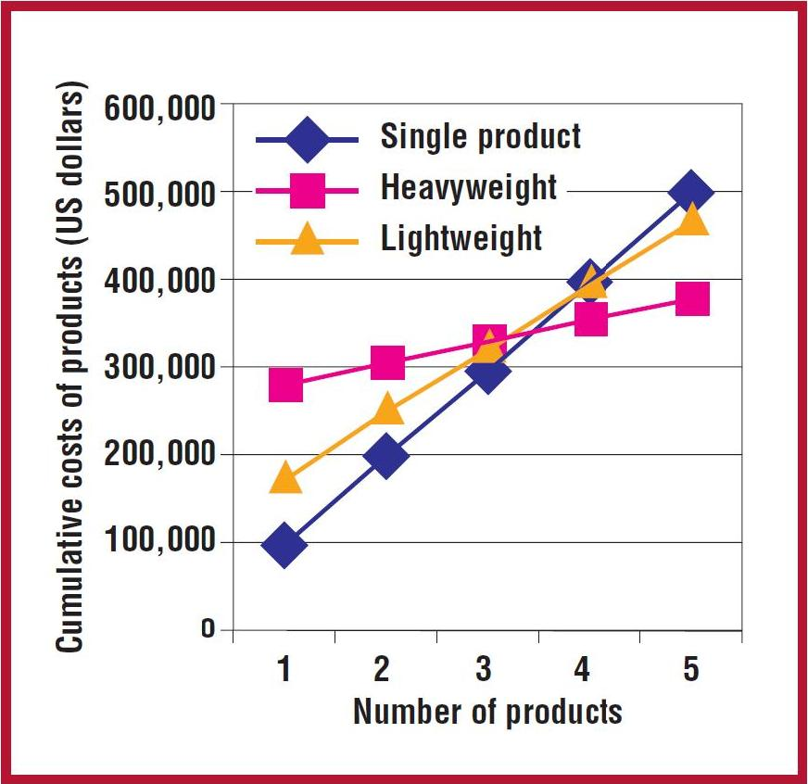
Figure 1 - Benefits of product lines
The figure shows the cumulative costs for individual product development (blue line) and two different product line development strategies (yellow- and pink lines). As the figure shows two different approaches to product lines exists as described below.
Heavyweight
A heavyweight product line is based on a proactive strategy where the reusable core assets are created before any products. The product line is designed and build from the ground up, with no constraints from existing products.
Lightweight
A lightweight product line is based on a reactive strategy, where core assets are extracted from one ore more existing product(s). As a result of this the product line will be constrained by the assets of the donor project(s), which might limit the quality of the resulting product line. The effort in building the product line will be less using this approach, but so is the potential reuse.
An interesting conclusion can be drawn from the figure. It appears that a lightweight approach will never be the optimum solution. When building less than three products, the figure shows that the single product approach is the most cost effective; above three the heavyweight product line approach is the most effective, meaning that the lightweight solution is never the optimal solution.
The following is a short presentation of the costs and benefits normally associated with product lines.

Costs
The costs in building a product line comes down to building the core assets. The assets are also needed for individual products (e.g. an individual product also need an architecture, requirements etc.), but extra work will need to into building these, in order to make them sufficient for supporting a product line. In addition to this the work of tailoring the individual will be added to the total cost.

Architectural patterns
Throughout the project various software disciplines that support product lines will be used. We expect to explore some patterns and architectural styles, which can support the transformation to a product line. It is expected that some of the styles and patterns will be tested for suitability by implementing an architectural prototype on the style or pattern.
Patterns of any kind are generic and well proven solutions to recurring design problems. Patterns can generically be described as a three-part schema that consists of a context, a problem and a solution [Buschmann 1996].
Context
The context describes the design situations where the problems exist.
Problem
A description of the problem under the given context. The very essence of the problem should be described, as well as more specific issues or forces e.g. requirements and quality attributes for the system. As with quality attributes in general, the forces can contradict each other.
Solution
The solution should solve the problem by balancing the forces in the best way possible under the given context. The solution includes two aspects: The static aspects, that is the structure of the system, and the dynamic aspects, that is the runtime behavior. In other words these aspects can be documented with a module viewpoint and a component & connector viewpoint, respectively.
The solution does not necessarily solve all problems. The solution may focus on a part of the problems and leave others untouched. For instance the Model-View-Controller focuses on decoupling the user interface from the rest of the system, but does not address other qualities such as security or performance.
Summed up [Buschmann 1996] define software architecture patterns as:
An architectural pattern expresses a fundamental structural organization schema for software systems. It provides a set of predefined subsystems, specifies their responsibilities, and includes rules and guidelines for organizing the relationship between them.
Software architecture patterns are high-level abstractions of the system that extract the essence of the solution. Patterns must thus be tailored for every specific use. [Buschmann 1996] describe a medium level pattern called design patterns, that specify the architecture for smaller units of the system. Examples of design patterns are the Publisher-Subscriber pattern and the Proxy pattern.
All patterns are used to achieve certain qualities. Since the design patterns are lower level than architectural patterns they more specifically address qualities such as modifiability, that is, the design patterns focus on smaller parts of the whole architecture. Thus, the design patterns can be used to address quality attribute scenarios by having a standardized way of incorporating a selection of tactis that give the system the wanted qualities.
Since patterns are well proven solutions to common problems and they are given names that are familiar to architects and developers, they are also a way of documenting the solution and help communicating the architecture to the stakeholders.
Possible patterns
We will concentrate on styles and patterns that may lower coupling in the system, and support product line development. Examples are repository style for decoupling persistence, and model-view-controller for low coupling of the user interface etc.
Model-view-controller
The model-view-controller is used to lower the coupling between a model of a domain and the presentation. Or in other words decoupling the user interface and the rest of the system, by dividing the system into three components
- The model that contains all data and business logic.
- The view that displays the model to the user.
- The controller that receives user input and manipulates the model accordingly.
The user interface is made of the view and the controller.
In order to support several types of products, we may benefit from having a Meta model for the persisted data, in order to interpret the data in different ways, in different user domains.
Prototypes
The prototype is expected to show a substantial amount of reuse across similar products. It will show how different variations can be implemented without violating the architecture which is a necessary property of a software architecture in a software product line.
Discussion of product lines
The report will contain a discussion of product line theory, with a focus on the claims that there is a rather big overhead in product line conversion compared to individual developed products.

Report outline
The following is an outline on the expected sections of the finished report. This is for reference only and is subject to change.
- Motivation
- Hypothesis/Problem statement
- Theory
  - Product line theory
  - Architectural patterns
  - Architectural prototypes
- Reconstruction of DrinkMixer
  - Architectural reconstruction theory brief
The process of architectural reconstruction is obtaining the documentation of the architecture for an existing system. The basic process is to Extract information from the system, abstract the data, and finally present the results. An example of a formal process for this is the Symphony process created by Nokia [6]. This process identifies three different artifacts, source views, target views, and hypothetical views. The source views are information that can be gathered from the existing system, such as abstract syntax trees, or other source code information. The target views, describes the system as implemented, by abstracting the information from the source views, and identifying architectural significant information. Finally, the hypothetical views exist, where other types of information is gathered about the system. This could be existing architecture descriptions, which may, or may not be in synchronization with the systems current implementation. It could also be presentations of the system, or documentation that could provide information on how and why particular architectural decisions have been made.
The process of architectural reconstruction is typically a manual, or in best cases a semi automatic process. When using tool support for gathering information from a system, the typical extracted information is static structure, if the source code is available. For other types of tool support, Island grammar [5][6] could could help identifying dependencies, and groupings of data structures and basically extract data from the system.. Also tools as discotect[7] support probing a system for architectural significant events, such as identifying call stacks of when e.g sockets are created. This can give som information on e.g. sequences in the system, and help reconstruct C&C views. The main problem with automated tools for extracting information for architectural reconstruction is that the information is representing the system in all details, where software architecture is an abstraction and an overview of the system, which is created to hide insignificant details. An example of this, can be seen, in the [Appendix indsæt reference, og indlæg autogenrerede diagrammer og manuelle genererede] automatic generated diagrams from the DrinkMixer, and the manually created static views, that has been created by manually analyzing the source code, and abstracting the details. When looking into the articles written on the topic of automated reconstruction [5], it can be seen that approximately 4/5 of all documents on automatic reconstruction of views and viewpoints are articles concerning module views. 1/5 of all articles are on C&C views, and only a single article is written on how to automatically generate allocation views. This indicates that the tool support for automatic generation of architectural views are somewhat immature, and that the topic is of great complexity, since the meaning of architecture is to omit details, whereas the system represented as source code or binary files contains all details.
The typical architectural reconstruction has a driver, which is founded in some sort of problem that needs to be discovered and fixed. In this case the problem is creating a business case of founding a software product line based on the existing implementation of DrinkMixers.
  - Static views
  - Architectural views
- Building the product line prototypes
  - Adding functionality to DrinkMixer
  - Identifying variation points
  - Creating strategies
  - Building architectural prototype(s)
  - Evaluating the prototype
- Evaluation & discussion

5 Related work
Architecture patterns
Problem
Description of the problem under the given context. The very essence of the problem should be described, as well as more specific issues or forces e.g. requirements and quality attributes for the system. As with quality attributes in general, the forces can contradict each other.
Solution
The solution should solve the problem by balancing the forces in the best way possible under the given context. The solution includes two aspects: The static aspects, that is the structure of the system, and the dynamic aspects, that is the runtime behavior. In other words these aspects can be documented with a module viewpoint and a component & connector viewpoint, respectively.
The solution does not necessarily solve all problems. The solution may focus on a part of the problems and leave others untouched. For instance the Model-View-Controller focuses on decoupling the user interface from the rest of the system, but does not address other qualities such as security or performance.
Summed up [Buschmann 1996] define software architecture patterns as:
An architectural pattern expresses a fundamental structural organization schema for software systems. It provides a set of predefined subsystems, specifies their responsibilities, and includes rules and guidelines for organizing the relationship between them.
Software architecture patterns are high-level abstractions of the system, that extract the essence of the solution. Patterns must thus be tailored for every specific use. [Buschmann 1996] describe a medium level pattern called design patterns, that specify the architecture for smaller units of the system. Examples of design patterns are the Publisher-Subscriber pattern and the Proxy pattern.
[This section may be put in front of the hypothesis section or integrated into the method section, if it make the flow of text more natural.]
In this section you outline what literature and other work your project build upon: papers, books, links to webpages, tutorials, etc. All references should be resolved in the reference section, that is do not use footnotes, or put the reference directly in the text. For an example, look how references are cited in
Bardram et al.[1].
It is good to address how your work extends, use, or build upon the cited work.

6 Conclusion
Your synopsis should clearly state: abstract, motivation, hypothesis, method, and (expected) analyses and results.
References
[1] http://sourceforge.net/projects/drinkmixer/
[2] L. Bass, P. Clements, and R. Kazman. (2003) Software Architecture in Practice 2nd Edition. Addison-Wesley, chapter 14 and 15
[3] Clements, P. and Northrop, L. (2002) Software Product Lines.
[4] McGregor, J.D., Northrop, L.M., Jarrad, S., Pohl, K. (2002) Initiating Software Product Lines. IEEE Software 19(4), pp 24-27
[5] Koschke, R. (2005). What architects should know about reverse engineering and reengineering. WICSA Keynote, accessed 2008-05-07. http://www.informatik.uni-bremen.de/%7Ekoschke/koschke-keynote.pdf
[6] van Deursen, A., Hofmeister, C., Koschke, R., Moonen, L., Riva, C. (2004) Symphony: View-Driven Software Architecture Reconstruction. In Proceedings of the Fourth Working IEEE/IFIP Conference on Software Architecture (WICSA’04), pp 122-132
[7] Schmerl, B., Aldrich, J., Garlan, D., Kazman, R., and Yan, H. (2006). Discovering Architectures from Running Systems. In IEEE Transactions on Software Engineering, vol 32, no. 7, pages 454-466
[Buschmann 1996] Buschmann, F., Meunier, R., Rohnert, H., Sommerlad, P., Stal, M. (1996) Pattern – Oriented Software Architecture – A System of Patterns. John Wiley & Sons

Currently [2], [3] and [4] are identified, but an analysis of available literature is expected to extend this list.

